* Class is a template or blue-print that describe the behaviour or properties that the object of its type support
* A class is a way to bind the data and its associated function together.
* When defining the class we are creating a new abstract datatype that can be treated like any other built in datatype.
* A class specification has two parts –
  + Class Declaration – it describes the scope of its member
  + Class function declaration – it defines and describes how the class functions are implemented. For e.g – Consider the class of CARS. There may be many cars with different names and brand. All of them will share same common properties like all of them will have four wheels, speed limit. So here, CARS is a class and wheel, speed limit are their properties.
* Class Declaration Syntax: (also available in same folder as **class_declaration_syntax.cpp**)

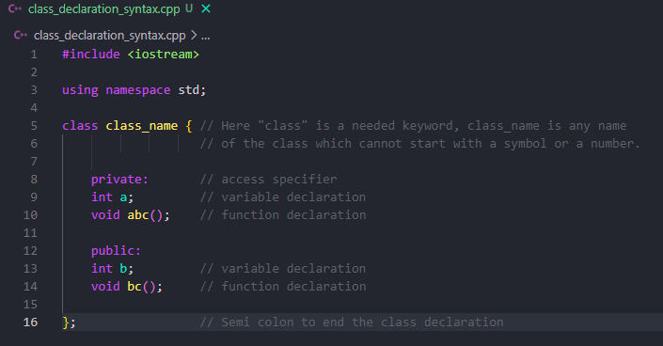

* The given class specifies that what follows in an abstract data of type class name
* The body of the class is enclosed within {} (curly brackets).
* The class body contains the declaration of variable and functions. These functions and variables are collectively called class members.
* The keywords public and private are the access specifiers followed by colon “:”.
* The class members that have been declared as private can be accessed by only from within class on other hand public members can be accessed from outside the class also. (Member methods and data members are private by default).
* Declaring or creating object.

When a class is defined, only the specification of the object is defined. No memory or storage is allocated. To use the data and access the functions defined in the class, you need to define an object.

**class_name object_name;**

* Accessing data member and member functions.

Data members or member functions can be accessed using (.) operator along with the class object.

C++ program to demonstrate accessing of data members. (available in same folder with name specified in image)

